|  |
| --- |
| Faculty of Applied Sciences and Technology |
| **XML/JSON Data Processing** |
| ITC5202 - Project |
|  |
| **Bharat Raj Verma and Sanath Tuli**  **N01510841 N01473612**  **Submission Date** |
| **8/4/2022** |

|  |
| --- |
| This document explains how to process XML/JSON data …………………………. |

Table of Contents

Step 1 1

Step 2 5

Step 3 8

Step 4 11

Step 5 15

Summary 18

# Step 1

(Describe the major steps for designing the JavaScript function(s), how you test this program, add some screenshots of the output )

In this step, we were supposed to fetch the title, author, its subreddit, the url, score and flair in a proper format.

We approached this problem statement with a table format design.

Initially, we are setting up the visual for textbox and search button and gave them unique ID’s & appropriate onclick function call.

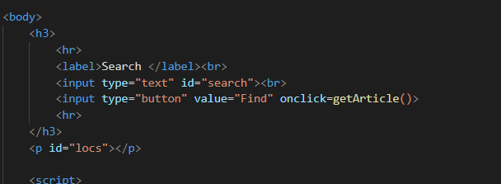

In the script, we are using the .val() function to store the value of the data inserted by the user into our variable.

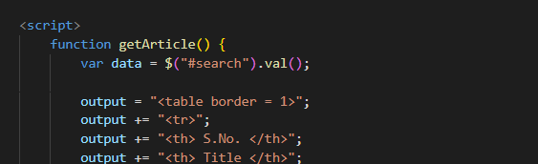

Further, we are implementing the real time value of the user inputted data into the API & using the limit feature of the API to get 100 records in the following way.  
  
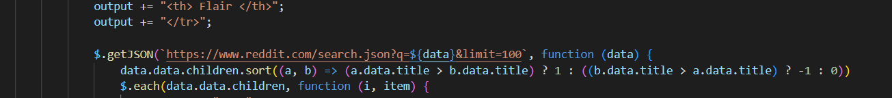

Further to sort, we’re using a shorthand for if-else statement to sort the title.

After this, we setting up the table content and displaying all the required fields from the array.

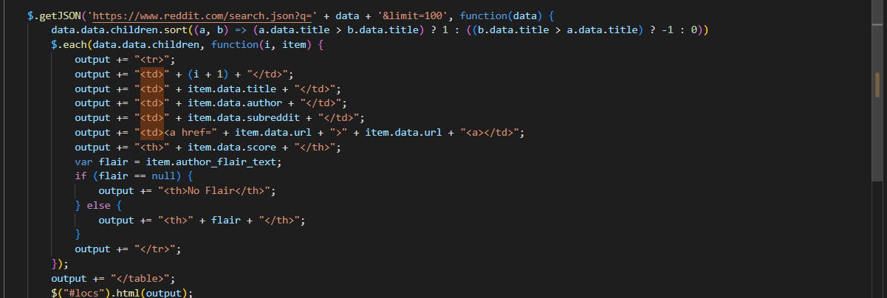

Using the .fail function of $.getJSON to handle all the exceptions.  
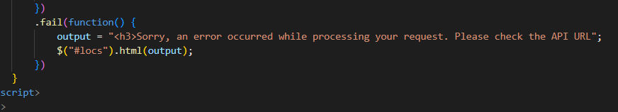

Outputs:



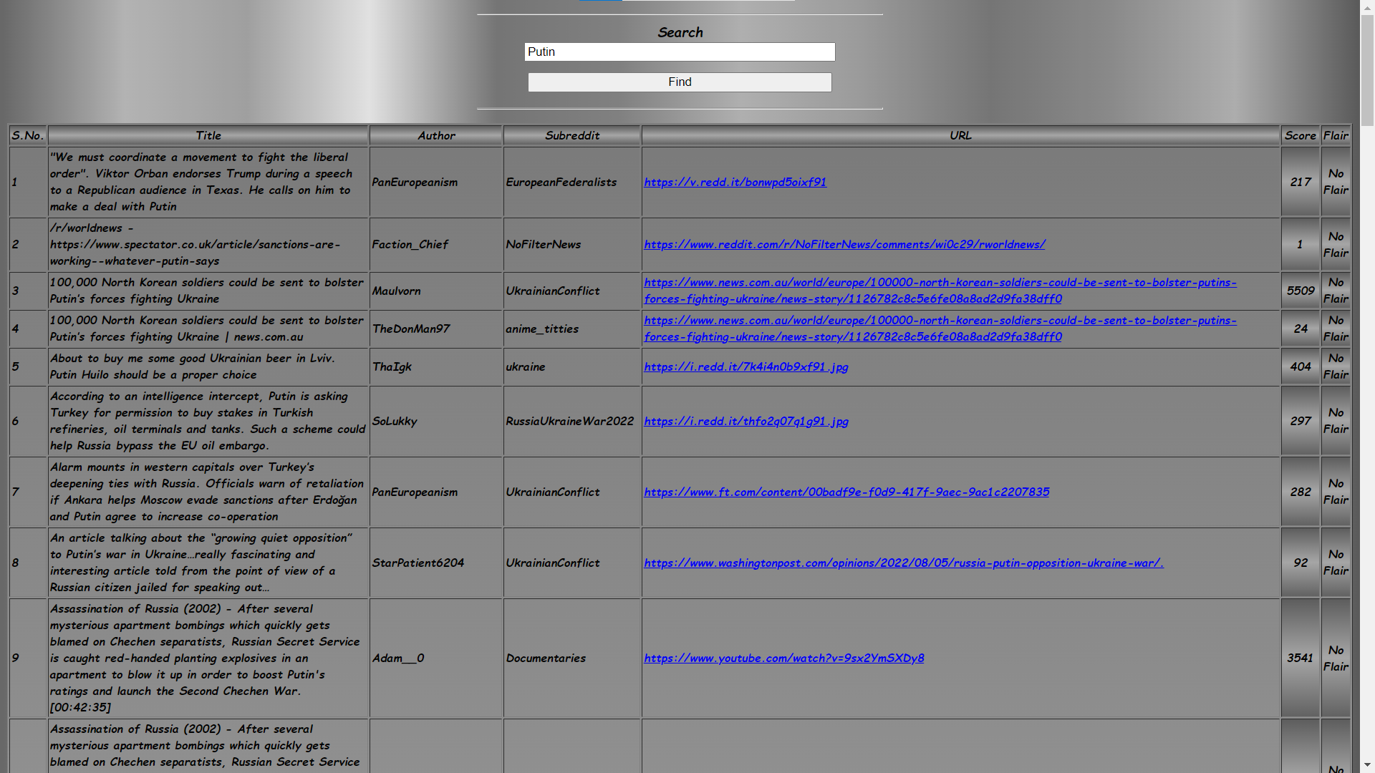

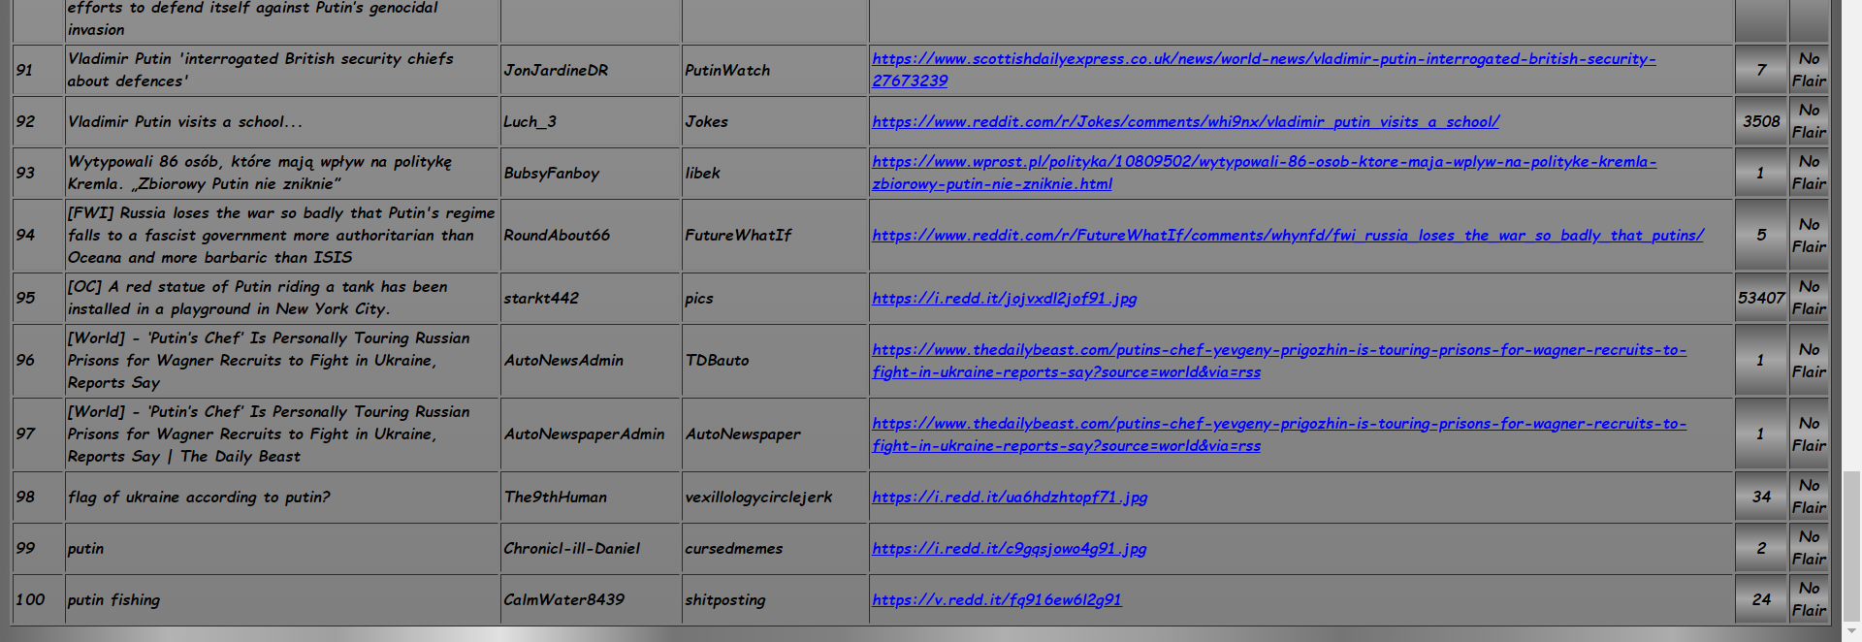

# Step 2

(Describe the major steps for designing the JavaScript function(s), how you test this program, add some screenshots of the output)

In this step, we were supposed to fetch the article body, author, its subreddit, URL, score and flair, in proper format by using the pushshift API.

We used the same design as step 1 for brainstorming this step2 as well.

For this, we are initially setting up the visual outlook of the program by adding all the text/label/button fields.

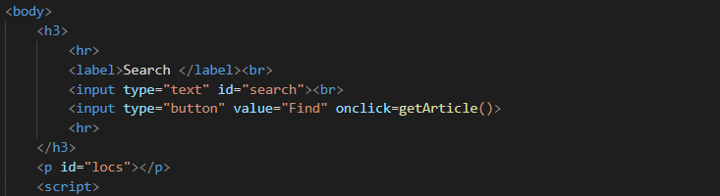

Here, we are using the appropriate unique ID’s and onclick function declaration.

Using the .val() function to get the value user would insert.

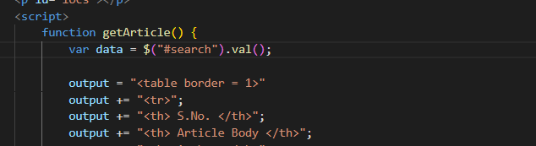

Speaking of the push shift API call, we have structured the API in the following way:

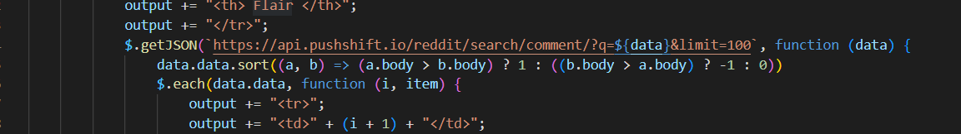

This will use the API call dynamically to search for the content and will limit & sort the data based on the body.

Further, we are designing the table content in order to show the appropriate content required for the step.

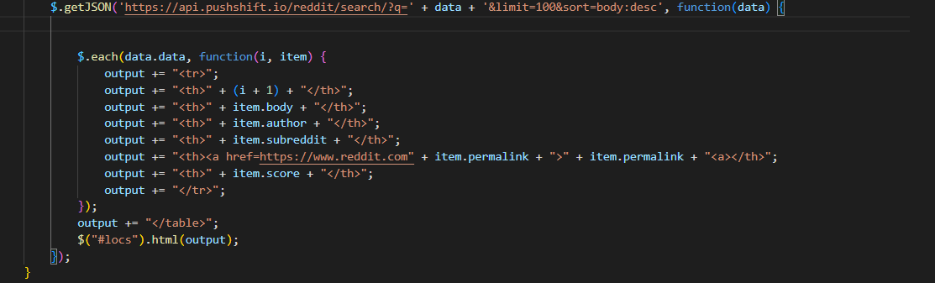

Using the .fail function of $.getJSON to handle all the exceptions.  


Outputs:

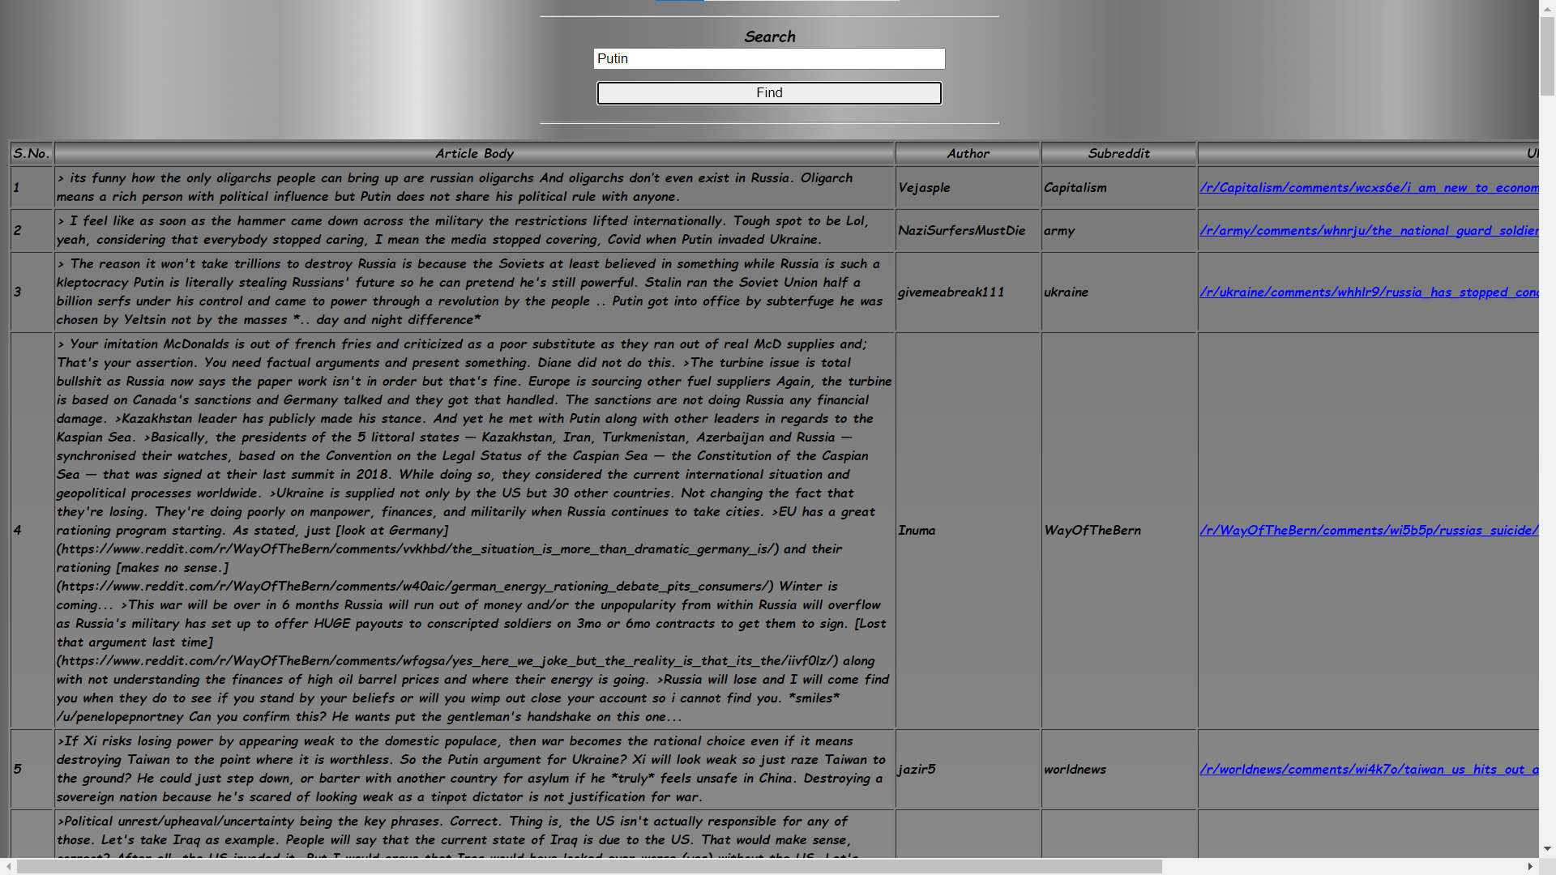

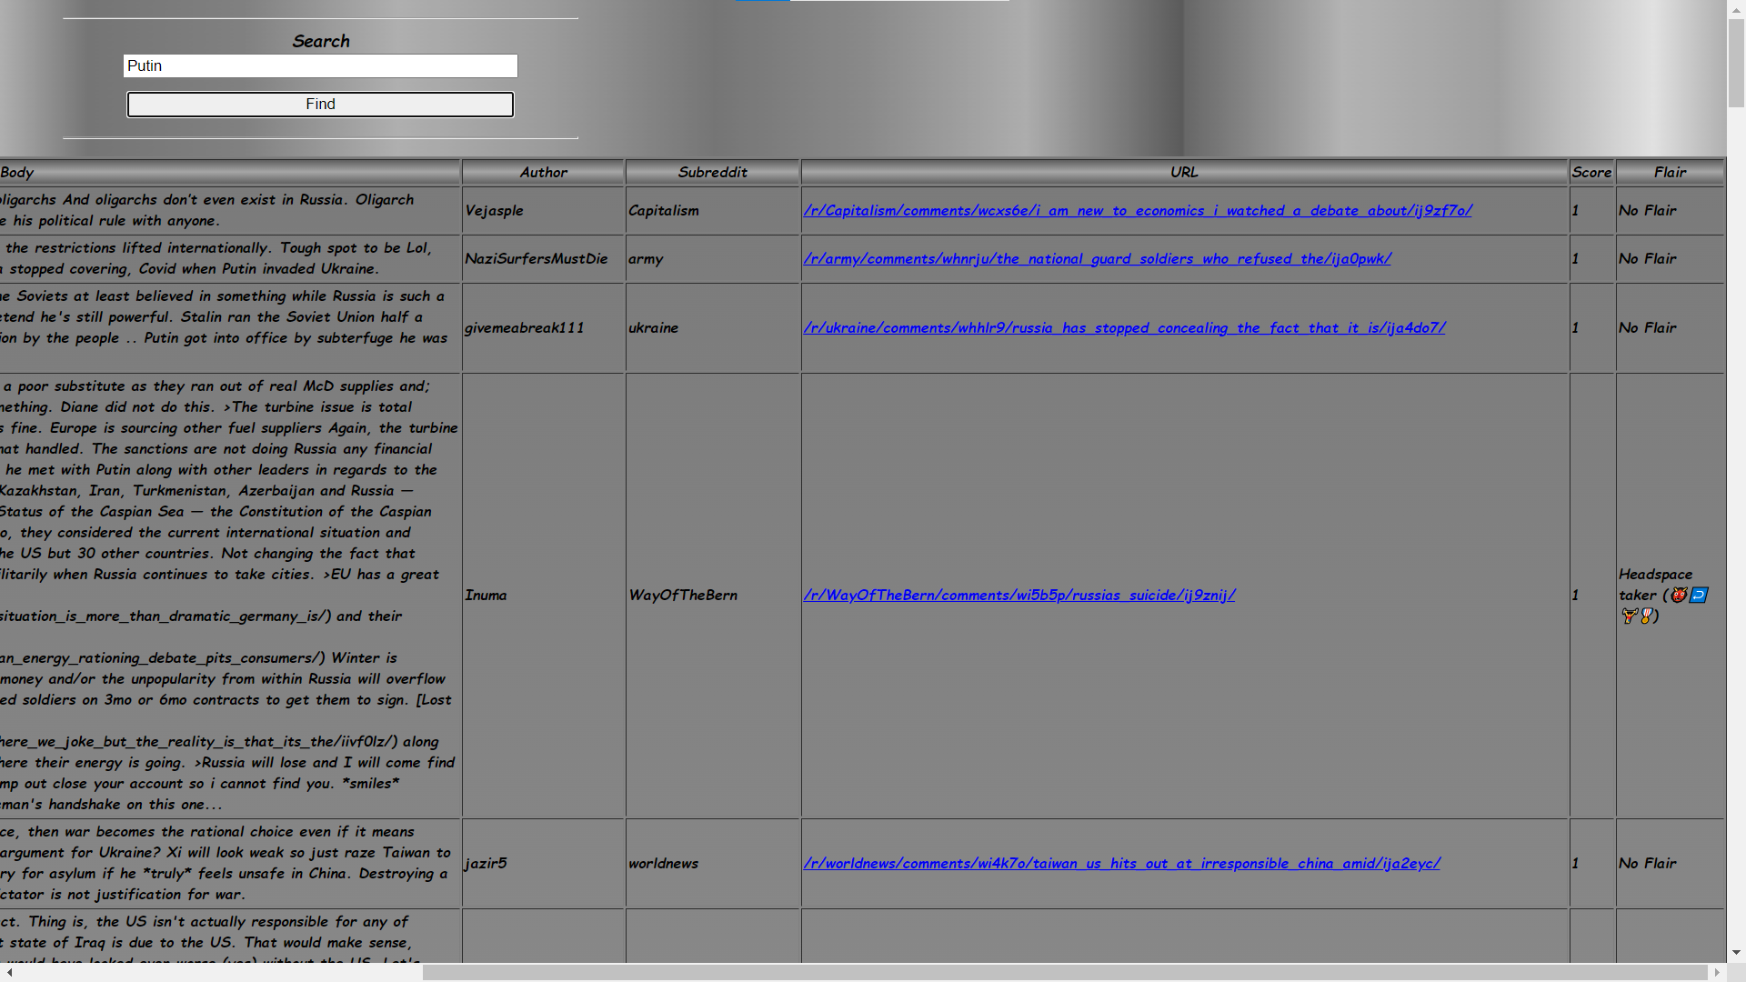

# Step 3

(Describe the major steps for designing the JavaScript function(s), how you test this program, add some screenshots of the output)

Here, we are supposed to displays the top 3 matching subreddits. In each subreddits, displays three top score posts, their authors, score, any related images, and flair of each post and for each we are getting the top 3 posts.  
  
So we are starting by setting all the text/label fields and giving them appropriate ID’s and function linkage through on Click.

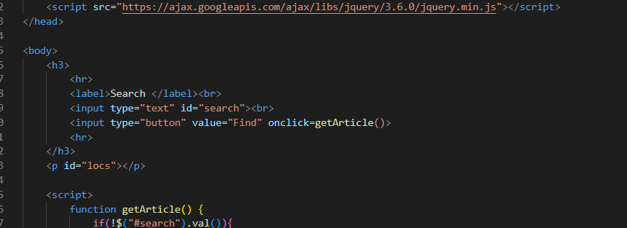

Running data validations.

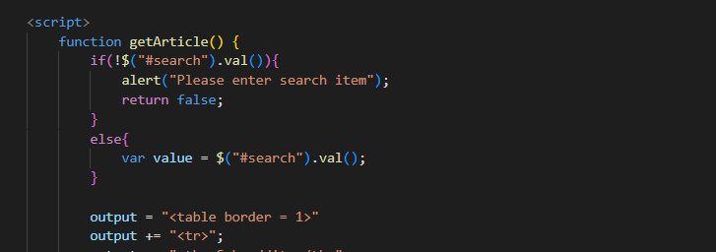

Setting the table structure and headers.

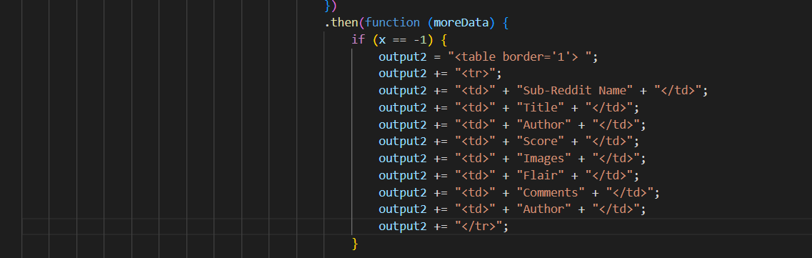

Now, we are fetching the API using below URL using Promise object and then displaying the top subreddits.

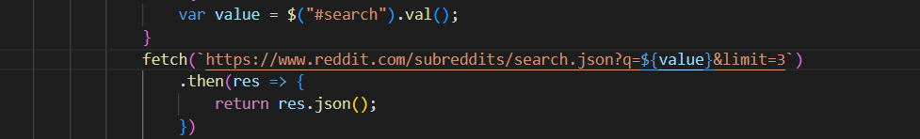

Now, we are fetching the API of each subreddits that will give the data of the subreddits.

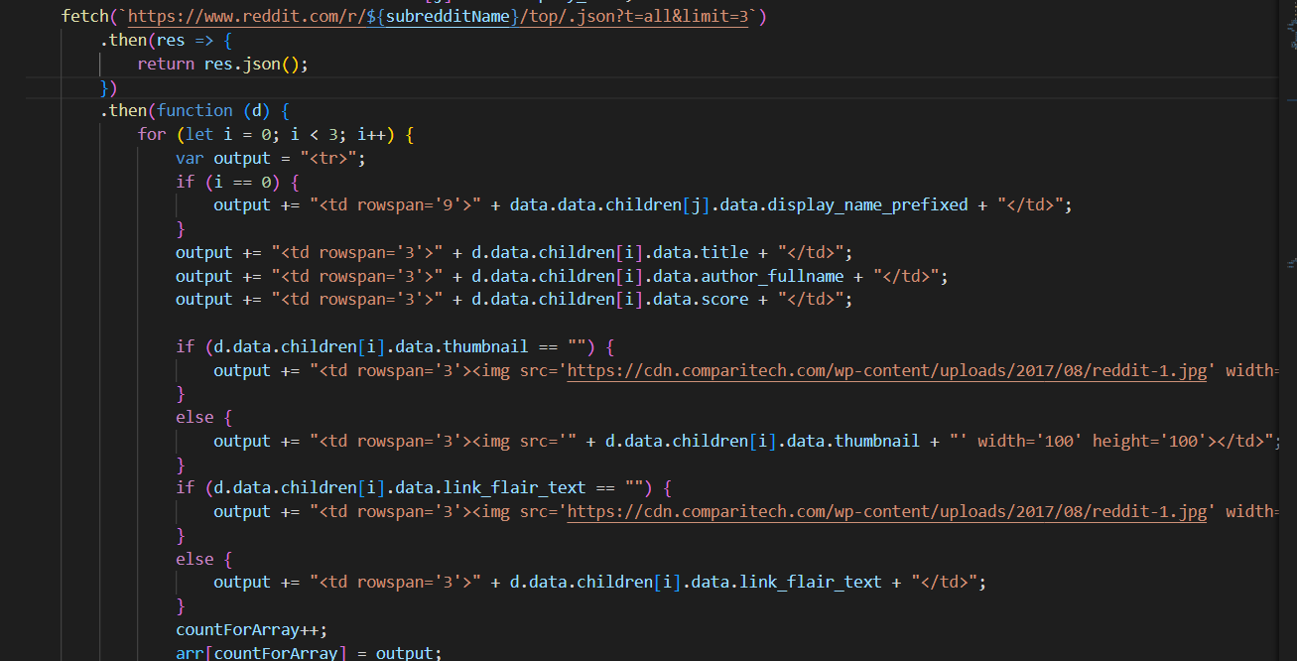

Again, we need to fetch the API using the permalink which will give the API of the post that we are fetching for each reddit, now the first index of the API will give the post and the second will give the comments on that post. And we are using sort =top which will give the top comments.

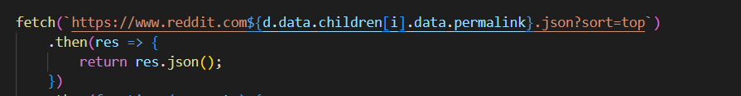

Outputs:

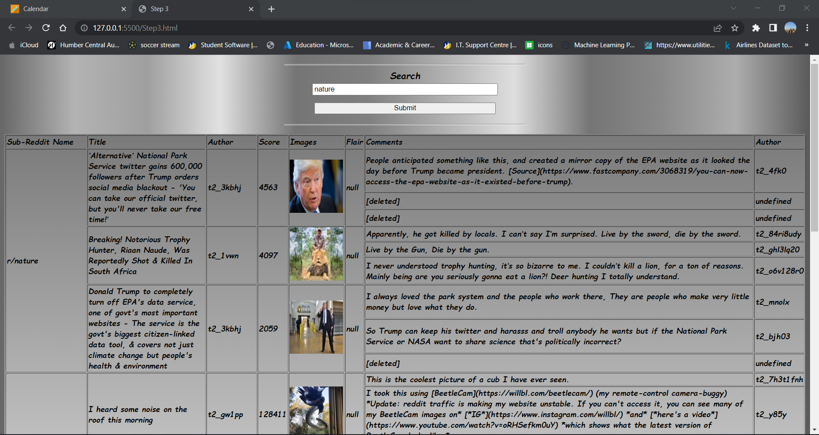

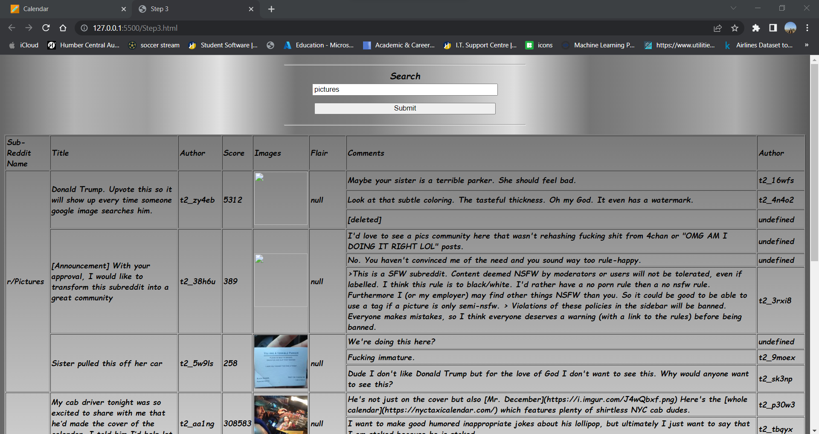

# Step 4

(Describe the major steps for designing the JavaScript function(s), how you test this program, add some screenshots of the output)

In this step, we are required to have a title or a summary of the reddit content , + a picture + score + subreddit + a link (read more) to actual article as shown in the picture below:

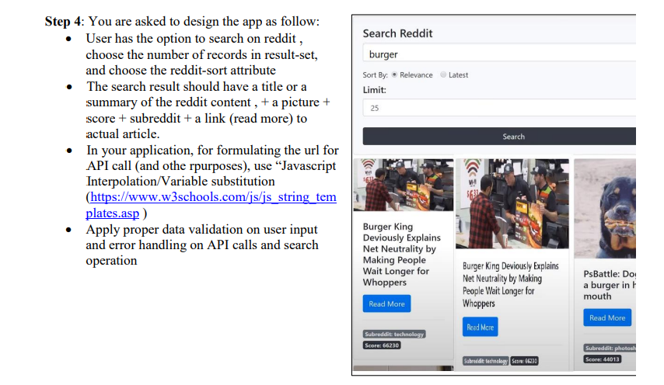

So here, we have used bootstrap framework for setting the data into visual block of cards.

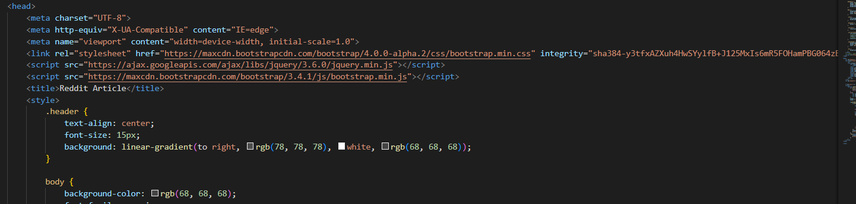

Storing all the user input values like search value, limit and the radio button value by storing them into variable using .val() function and using the interpolations in the API to fetch user inputted dynamic data.

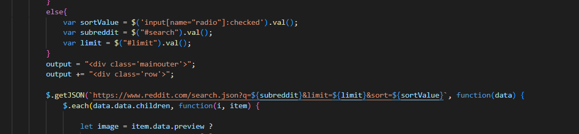

Ahead of this, we are providing the logic for our table to structure the data.

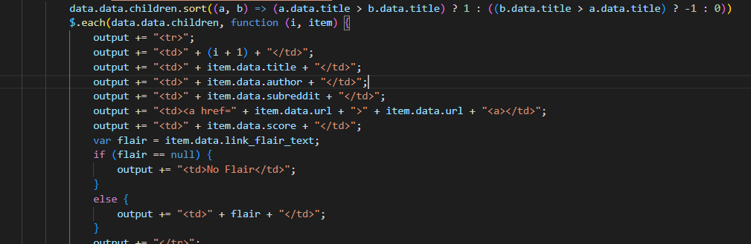

At last, we are using the .fail function to handle exception on the API.

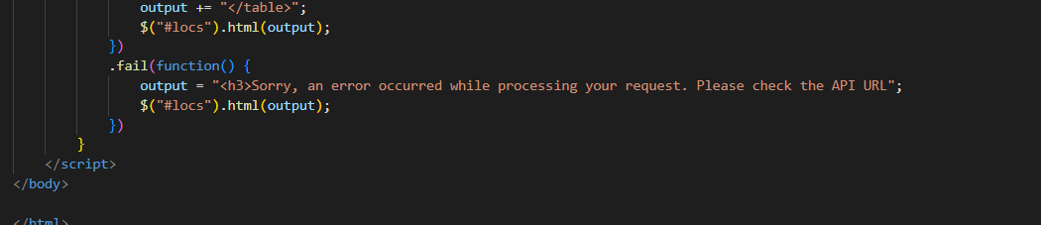

Outputs:

Using data validation.

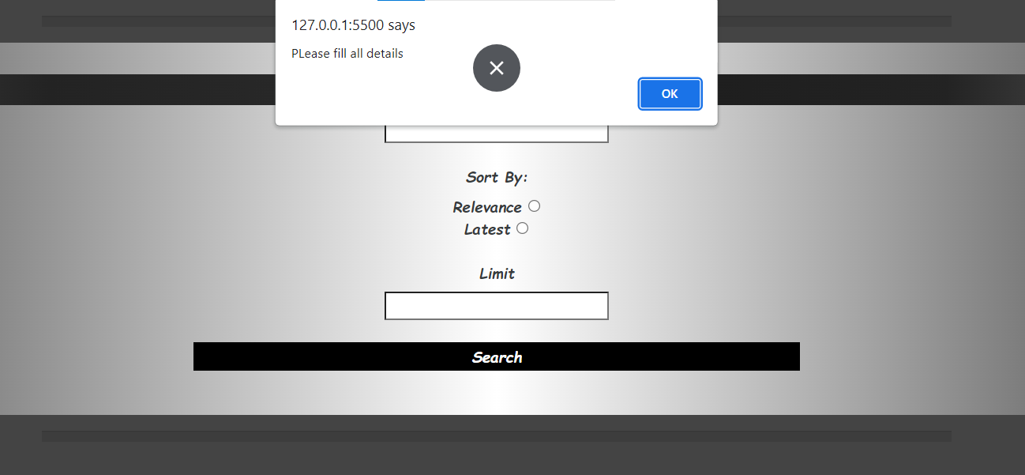

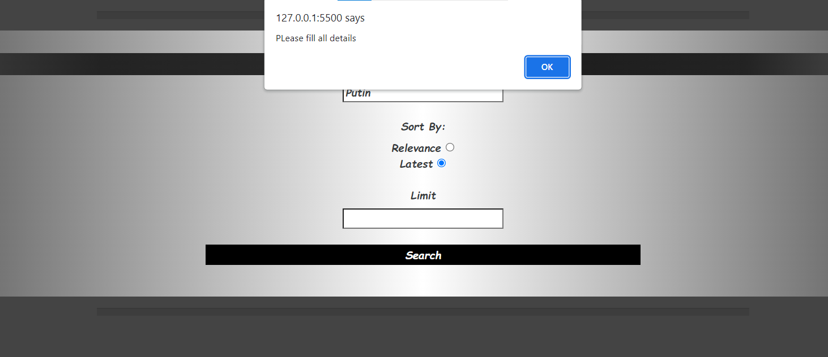

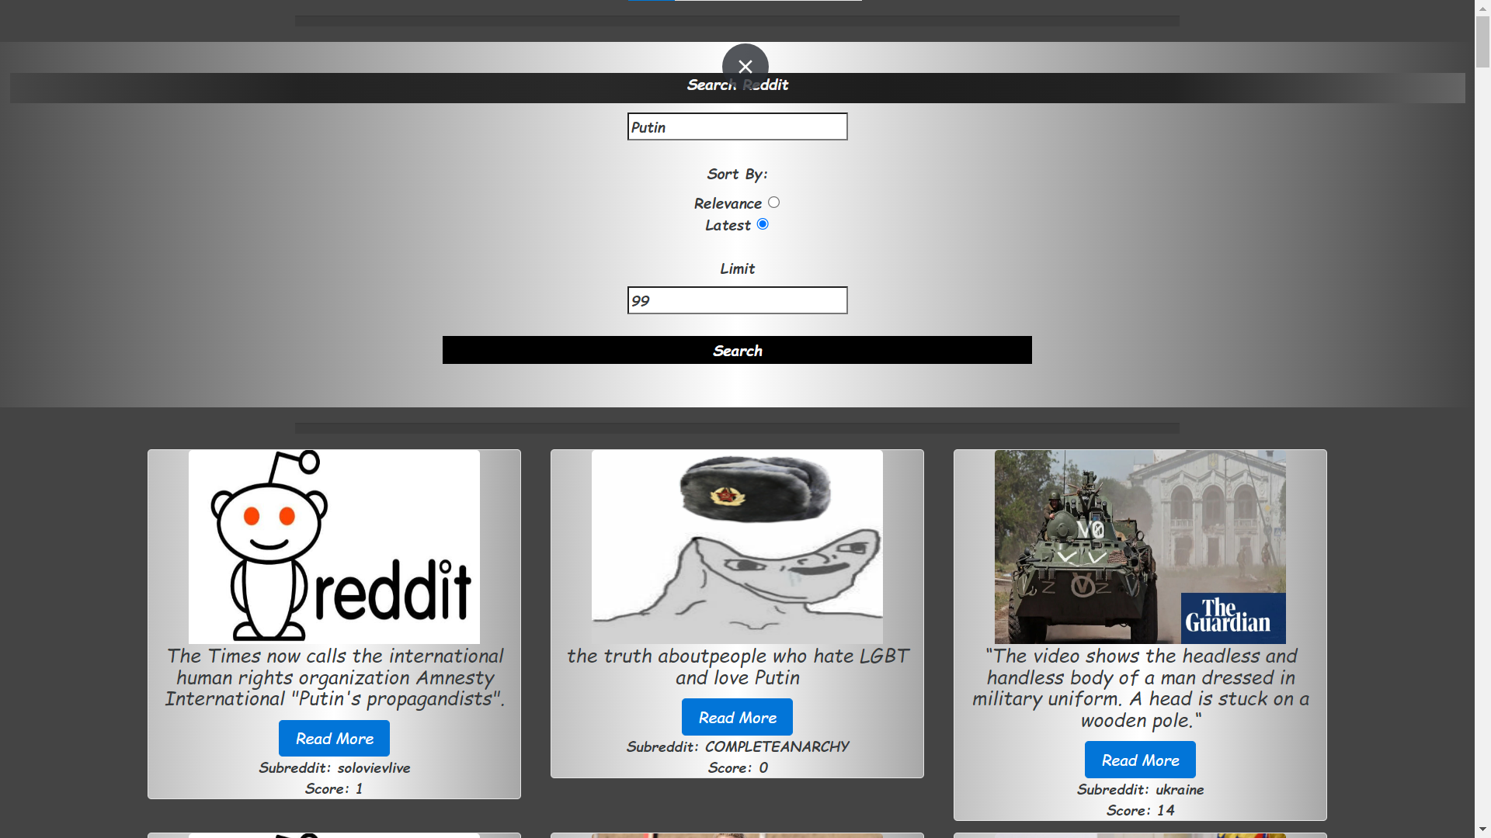

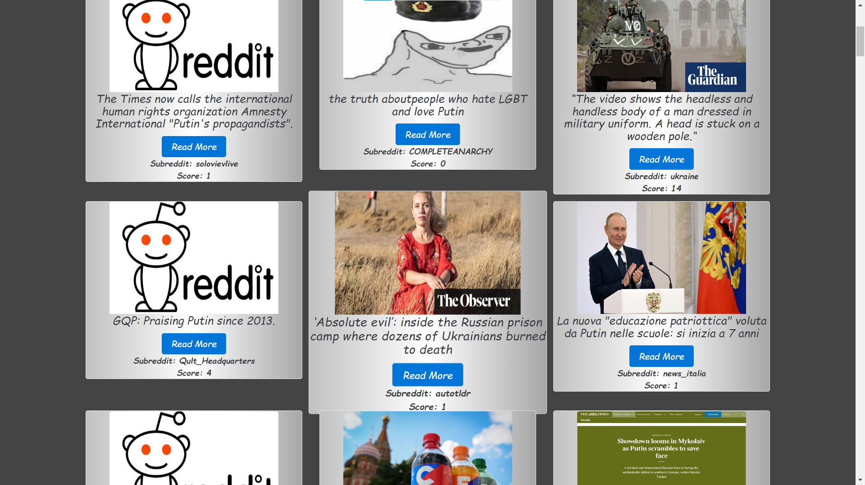

Using on hover features.

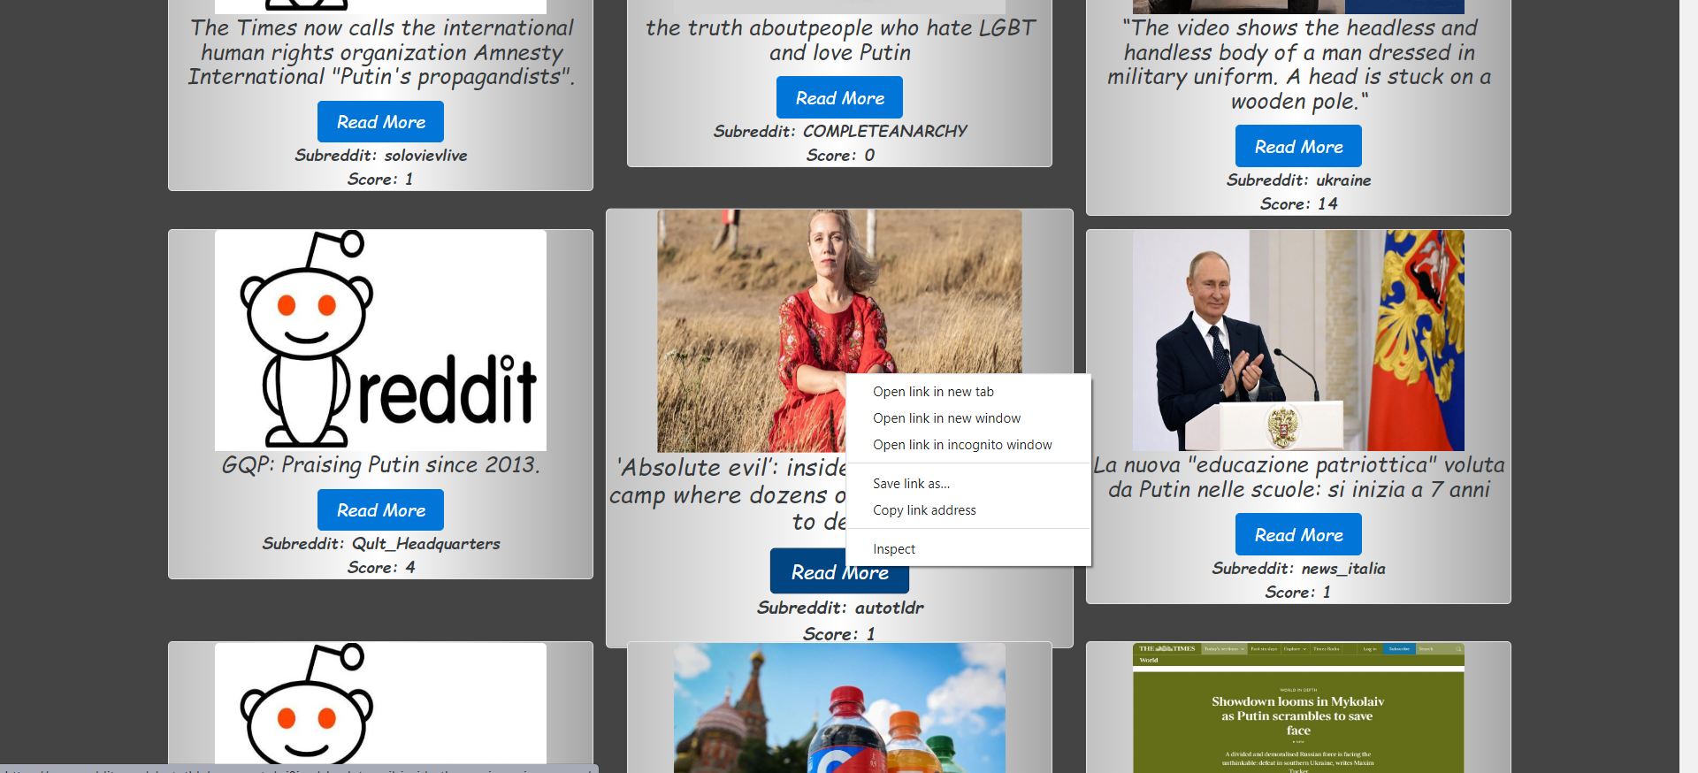

# Step 5

(Describe the major steps for designing the JavaScript function(s), how you test this program, add some screenshots of the output)

The major steps involved in the step-5 were:

Setting up the XHR object

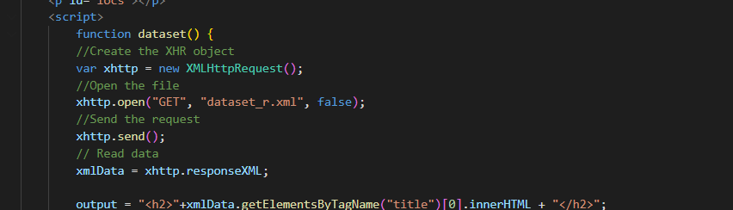

Setting table to structure the data for ‘entry’ object.

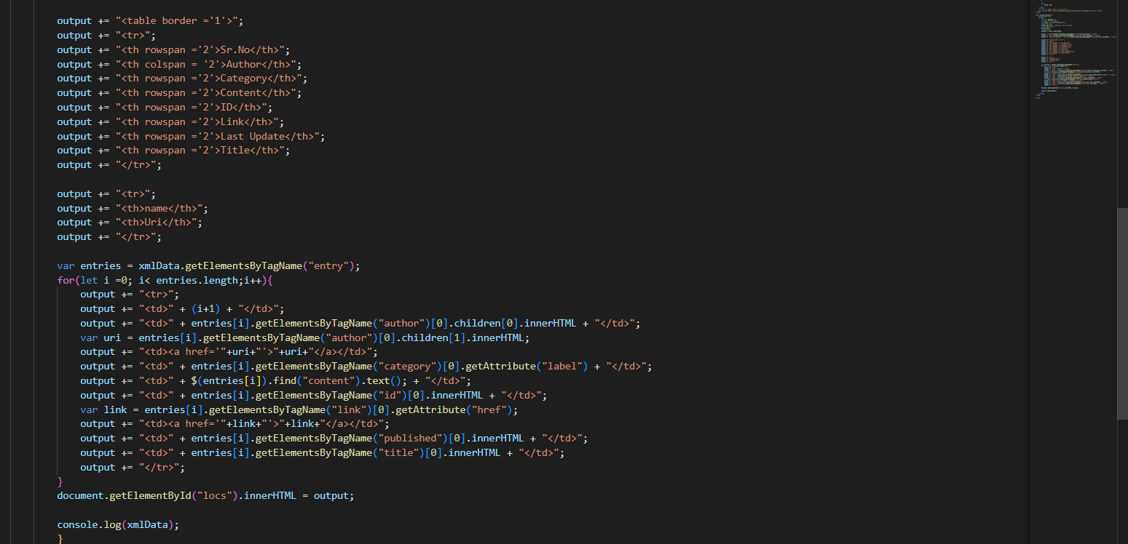

Outputting all the data to the front end by using innerHTML on the element attribute.

Outputs:

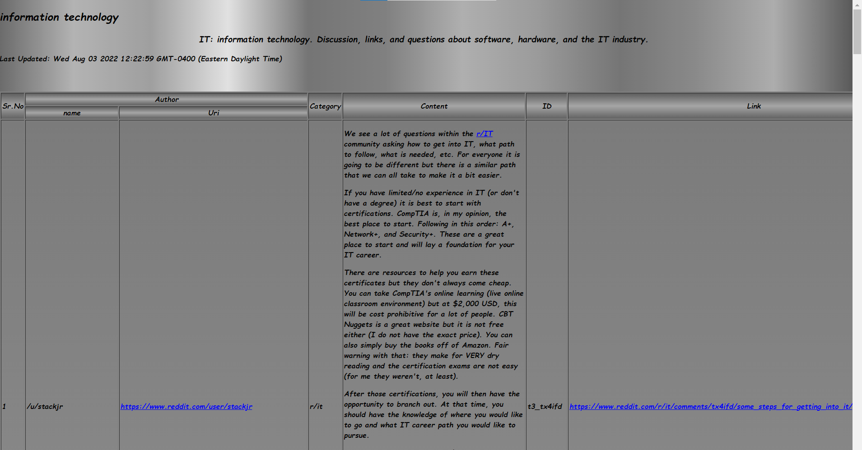

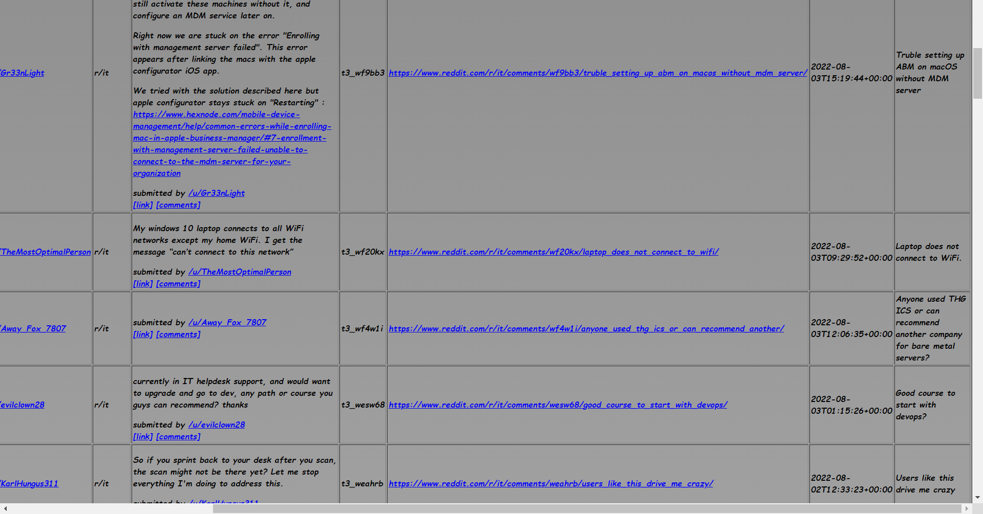

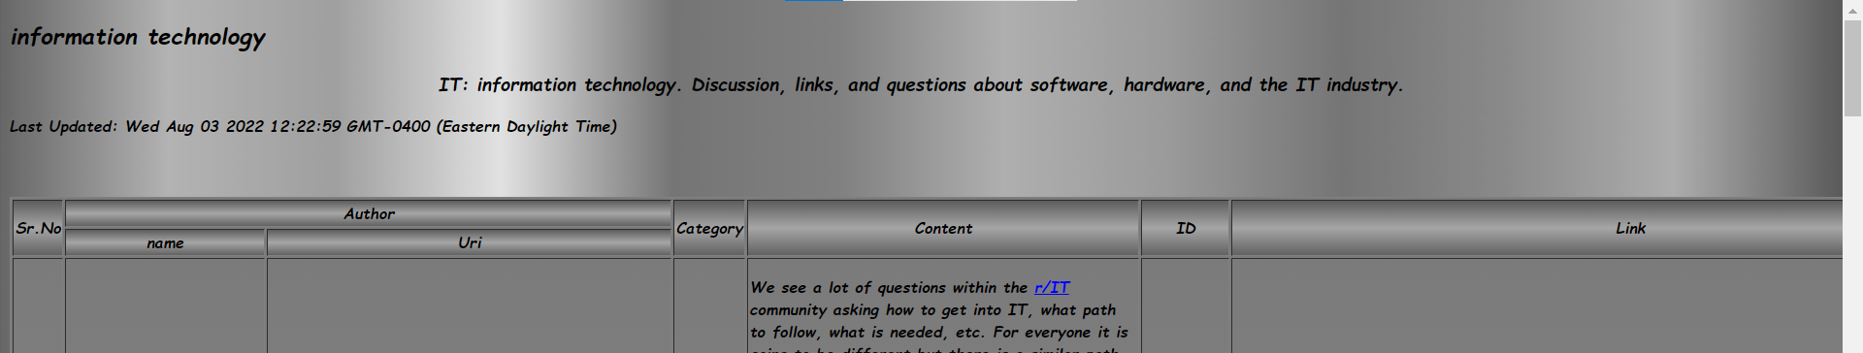

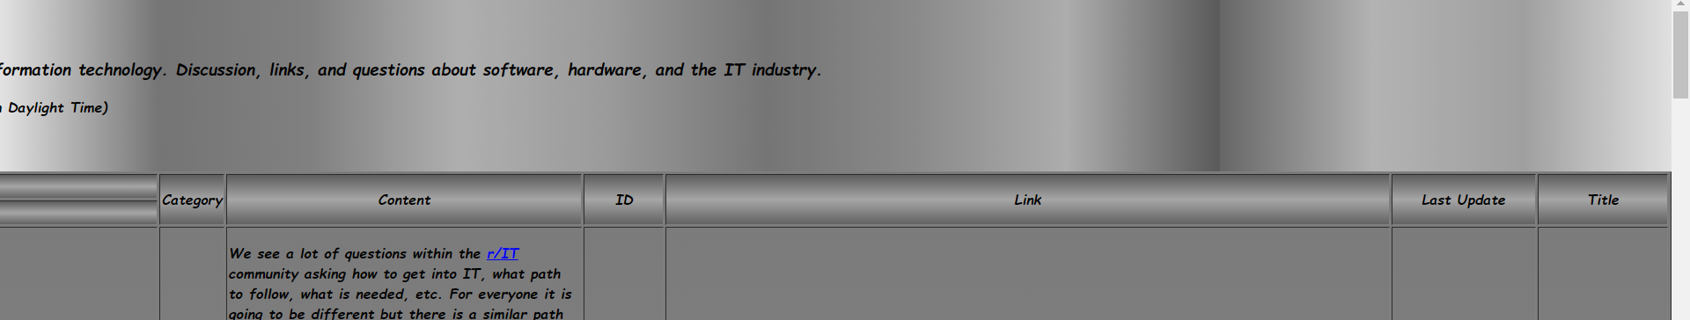

# Summary

(Describe how did you divide the work, share your feedback about this project like new points that you learn, challenges, …)

This project was surely a challenging piece of task but we definitely learnt a lot on how to manage our efficiency.  
  
Regarding the work division, we kept it planned to equity of tasks and further breaking them into minor deliverables by hypothetical deadlines.

The XML processing was another dive back to the previous weeks so we both took the initiative for that.

Regarding Step 4, little of designing part of done more by N0147312 and the scripting part was done more by N01510841.  
  
Rest of the parts were more or less equally divided and were worked upon in chunks.  
  
We learnt new concepts like using the variable substitution and using the script dynamically, which was a great learning experience for us.  
  
The sincere thanks to yourself for giving us this embarking opportunity.